**OCTOBER 2017**

ST. PAUL’S EVANGELICAL LUTHERAN CHURCH

**Who’s Hungry?**

Each fall kids flock back to the classroom where there is both joy and scorn for the variety one encounters for school lunches. As men mount their machinery in October, wives and others will be on call as to when they can deliver lunch or a treat in-between hauls. Everyone’s got to eat. It’s just a matter of what and when, especially when you’re busy.

As the devil was tempting Jesus in the wilderness, he tried the same old trick he had in the past: “Get people to focus on the meal rather than the Maker.” The Hebrews were lead into this temptation time and time again, even after God gave them a land flowing with milk and honey. But Jesus, met the devil head on: “**man shall not live by bread alone but by every word that proceedeth from the mouth of God**” (Deut. 8:3; Matt. 4:4). As much as we can all use 3 square meals a day, even more so we need God’s Word.

Our tummies tell us when our bodies have gone too long without food. Our souls tells us if we’ve gone too long without the Word of God. If you lose your appetite it means you’re sick or dying. If you have no appetite for a long enough time… it means you’re dead. If we have no desire to hear God’s Word or be forgiven in Christ’s church, we have no faith. Luther calls is despising “*preaching and His Word*” in the 3rd Commandment.

Our bodies go in cycles. Hunger, eat, rest and repeat. Our souls go in cycles. We’re not monks. Lutherans are totally against the idea that we should be cooped up in church praying and reading the Bible 24/7. That’s wrong. It’s as wrong as eating food all day long and never working or helping others. But the opposite is just as deadly. If we don’t have a steady diet of God’s Word—our faith will starve.

In Ezekiel 3:3 and Revelation 10:10, God commands the prophet and the Apostle John to actually eat a scroll of God’s Word, and after tasting it they both say “**it’s sweeter than honey**.” That’s how good God’s Word is for sinners. It’s sweet. For those who are so busy in the classrooms, in the fields, or in the kitchen, when you finally get a second to sit down and take a bite, it’s delicious! The same is true for all sinners in our church who are tempted by the devil each and every day to place our earthly meals before our heavenly Maker. Good thing the Word of God comes to us in the bread of heaven, sweeter than Halloween candy. Good thing God commands us to eat the Word wrapped in Jesus’ flesh and blood for the forgiveness of sins and strengthening of faith.

If that’s true for you reading this, it’s true for others as well. Our weekly attendance in Divine Service is 80 out of 350. That’s only 23% of our family fed by the Gospel. Less are fed with Christ’s body and blood. Individually we may be getting fed, but corporately…we’re starving. God’s got the meal. Who’s hungry?

**GOAL**:

* Who in our congregation could use a good meal of God’s Word? How are you going to get it to them?
* Once a day: pray with your family (See, Luther’s Daily Prayers in the Small Catechism).
* Once a week: read the Small Catechism and receive God’s Word and Sacrament in church.
* Once a month: pick a hymn and learn it together. [In October, we’re singing Lord, Keep us Steadfast in Your Word (LSB 655)].

Pastor

**LCW**

Breakfast & Bible Study

Saturday, October 14, 2017

9:00 A.M.

St. Paul’s Fellowship Hall

ALL ARE INVITED

**PLEDGES**

October 1st, all members are invited to fill out a pledge to help their own household plan to hear, learn, and support their congregation. Pledge Plans will be disbursed that Sunday.

D:\Color\pledge_972c.tif

****

The regular Quarterly meetings will take place in October. On Wednesday, October 12th, Trustee’s will meet at 6:30 p.m., Council will meet at 7:00 p.m., Elder’s will meet at 8:00 p.m.

The Voter’s meeting will be Sun., October 15th after church in the fellowship hall.

Here’s a few items on the Voter’s Agenda:

* Budget
* Nomination Committee

**MINISTRY EXCELLENCE FUND**

You can give matching funds to support Pastor in paying off his Seminary debt.

Any Funds given for this purpose should be made payable to St. Paul’s and marked for the Ministry Excellence Fund.



**LWML SUNDAY**

We will celebrate LWML Sunday on October 1. All members are invited to wear purple. We will have a noisy collection: monies go toward LWML mites.

[](http://www.lwml.org/home)



Thank you to Barb & Denny Mordhorst for donating the altar flowers this month.

**SUNDAY SCHOOL**

On October 22, the Sunday School will do a service project. After church they will go to the Ute cemetery and clean off the stones and then back to the church for pizza.

[Orphan Grain Train](http://www.ogt.org/) In the month of October we wi**l**l be taking donations for the Orphan Grain Train. Boxes will be in the back of the sanctuary. Please put the clothes in bags. Thank you for your donations.

**ALL SAINTS**

Join us All Saints Sunday, Nov. 5 for recognition of the faithfully departed in this last year: Michael Berens, Delores Mohr, Ervin Kiepe.

**HURRICANE OFFERING**

Thank you to all that give to Hurricane Harvey through St. Paul’s. 100% of the funds will be sent to the Texas, Southern Districts, and LCMS disaster relief efforts. In Oct. we will have a door offering for Hurricane Irma relief efforts.

**“THY STRONG WORD”**

**‘**Thy Strong Word’ is a daily devotion airing at 6:25 a.m. Monday through Saturday on KDSN 107.1FM).

Oct. 2-7 Rev. Richard Merrill (vacancy)

Triple Parish, Charter Oak

Oct. 9-14 Rev. Connor (vacancy)

Trinity, Manilla

Oct. 16-21 Rev. Merle Mahnken Immanuel, Schleswig

Oct. 23-28 Rev. David Loeschen

Bethlehem/Our Savior

Oct. 30-Nov.4 Rev. Richard Merrill

St. John, Charter Oak

**RECIPES**

Maple Heights will be celebrating their 50th Birthday in 2018.

They are making a cookbook and are asking for your favorite family recipes. Make sure your name or in memory of, is on the recipes.

You may drop them off at the Maple Heights front deck, give them to Jo Thies or put them in the “orange” box on the table in back of the church.

Submit before the end of the year.

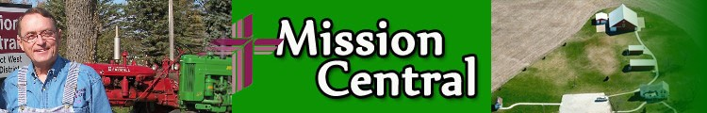

For more information you can go to http://www.missioncentral.us/ and click on the events.

**BAPTISMAL BIRTHDAYS FOR OCTOBER**

We are listing Baptismal birthdays to remember and celebrate the day we were adopted into the family of God through the washing of the Holy Spirit. Those having Baptismal birthdays in October are:

Sara Purcell 2

Don Petersen 4

Sandy Bauman-Eldon Teut 6

Liam Gray 7

Duane Mordhorst-Ethan Jones 9

Karen McCall 10

Dylan Hanson 11

Shirley Gosch-Lynette Thies- Angela Teut 14

Aaron Folk 18

Darin Wood 21

Wyatt Hinds 23

Dennis Nelson-John Thies-Keegan Bretthauer 24

Grace Manley 25

Alyse Bretthauer-Leona Goslar-George Hull-

Becky Meadows-Mike Ohlmeier 26

Sally Goslar-Charlys Folk 27

Elmer Mordhorst-Shane Sorensen 28

Nisha Hull 31

**NEWSLETTER SPONSORS**

Please contact the office if you’d like to sponsor the newsletter. The cost is $37.

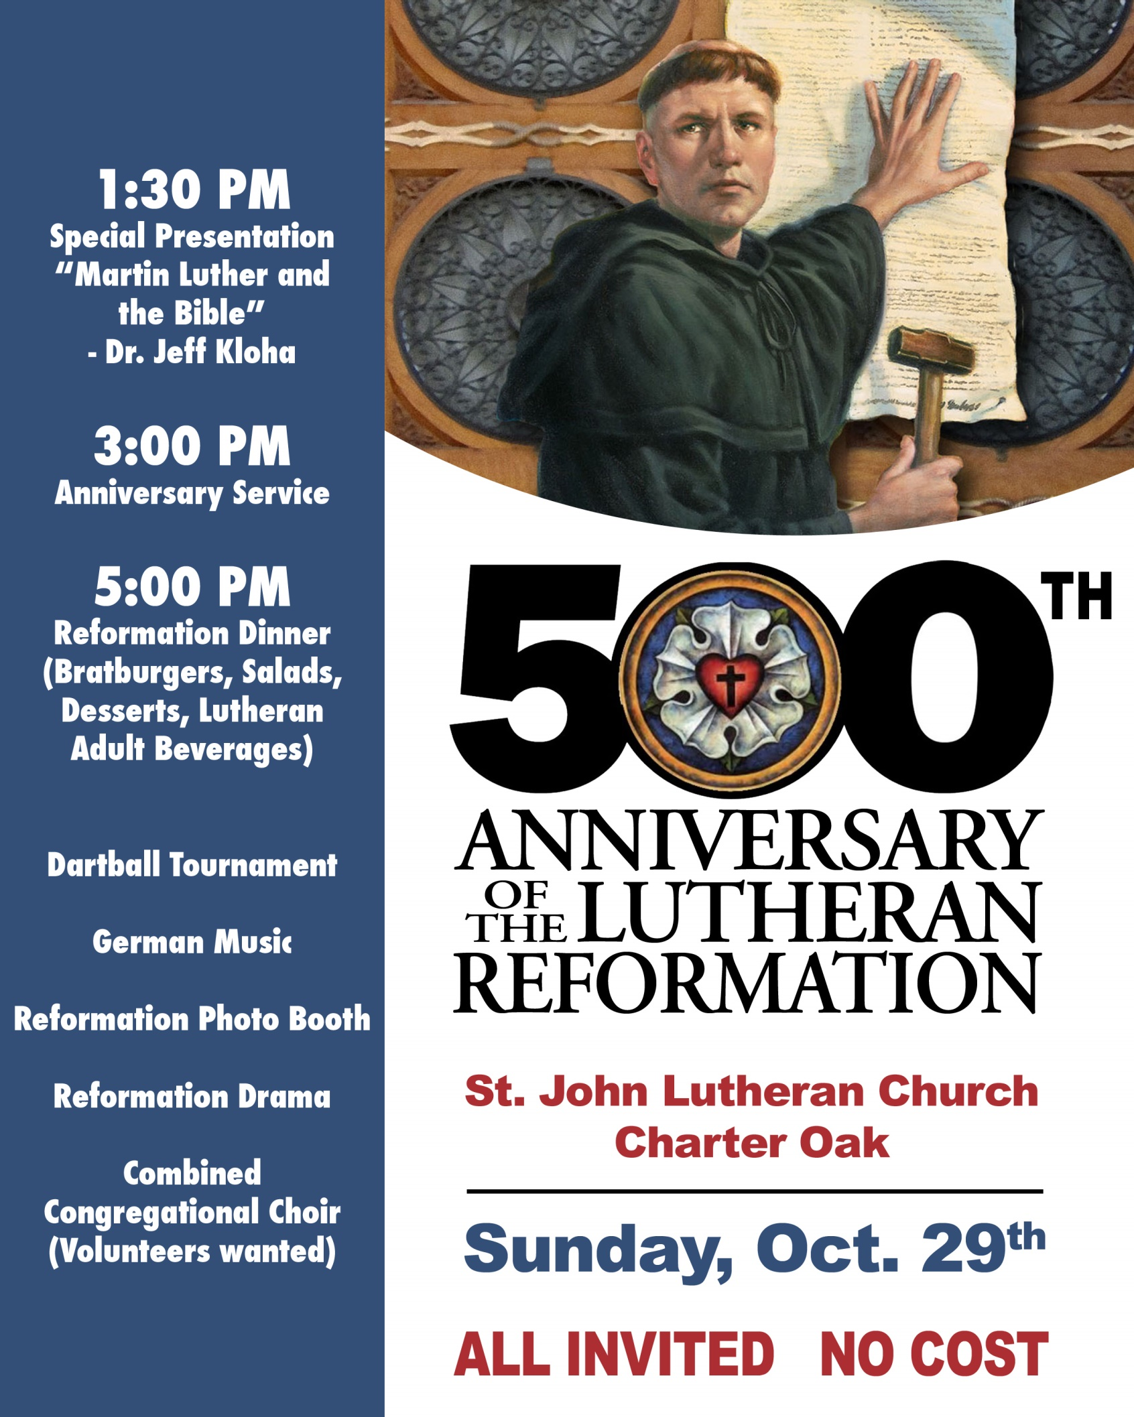

**SERVING THE LORD IN GHANA NEWS FROM THE SCHUMACHERS**

Lutheran Academy hosts the ELCG Pastor’s Conference



Rev. Dr. Robert Bennett is not a new face to the Ghanaians in the Evangelical Lutheran Church of Ghana (ELCG). He has

made many trips here to support the ELCG in pastoral formation and in pastoral continuing education. This year the topic was

very different from those of past instruction. The clergy and seminarians were given a copy of his first book I Am Not Afraid: Demon Possession and Spiritual Warfare. Dr. Bennett lectured on the topic, assigned readings, and coordinated small

and large group discussions.

The culture here is steeped in ancestor worship including communicating with the dead through the use of a diviner, funeral rites to show honor to the deceased, and daily rituals to please the dead, all so that blessings, not curses, will befall you. One sight common among the people is not finishing all the water in one’s glass or the food in one’s bowl, no matter how hungry the person may be. This extra water or food is thrown on the ground as a gift to the dead which is believed to bring blessings to the one sharing the food or beverage.

Dr. Bennett discussed the proper understanding of the doctrine of justification, which required the acknowledgement of the existence of Satan and all his powers. He continued with the reading of many biblical references like Matthew 15:21-28, showing Jesus’ power over demons. He emphasized, pastors need to exercise critical discernment in all matters of possible demon possession. He also explained the extreme importance of catechizing all the people involved, so they put their hope and trust is in the Triune God: Father, Son, and Holy Spirit.

**Life at the ELCG Seminary**



***(L) Seminarian Joseph Asaana, Rev. Schumacher, Vicar Jacob Wassah enjoying time together;***

***(R) Rev. Issah Gajah and son***

***Seminarian Paul Gajah, all in***

***attendance.***

The Seminary was filled with about fifty men coming together for the conference. From the expressions on the faces of the above men, you can see it was a time of good Christian fellowship. These Pastors of the ELCG serve 200 congregations and 300 preaching stations. It is essential they receive time for continuing education, as well as time for fellowship with one another. They worshipped, joined in devotions, and sang hymns and local songs. Being renewed in the spirit, they returned home to shepherd the flock that God has entrusted to their care. The photo on the right is of a very proud father whose son is a new seminarian. Paul was eager to introduce his father to us. The father is honored to have his son attending the ELCG seminary, a long distance from Kpanlori in the Bunkpurugu/ Yungoo area of northern Ghana. The six new seminarians, ages 20 to 37, bring youthful energy and excitement. These men have been youth leaders in their churches and have been chosen by their pastor to begin their path to becoming pastors. These young men worked very hard to help the other students to clean and prepare the seminary building and compound for their guests. The students have traveled home for a short three week break, before returning to the seminary on October 5th to begin their second term of this school year.

To support the LCMS through the work of *Rev. and Mrs. Steven Schumacher*, you

may send a tax-deductible gift to: The Lutheran Church—Missouri Synod, P.O. Box 66861, St. Louis, MO 63166-6861 OR Mission Central, 40718 Highway E 16, Mapleton, IA 51034 Make checks payable to The Lutheran Church—Missouri Synod. Mark checks, “Support of Schumacher/Ghana.” Gifts can also be given securely online through the LCMS website, on my online giving page at *lcms.org/schumacher*.

**SERVING THE LORD IN URUGUAY NEWS FROM THE SHARP FAMILY**



**On the left, the plans for the first new Lutheran church facility in Uruguay in 70 years; on the right, the congregation and visitors gather for the laying of the cornerstone.**

We were blessed to participate in an historic day for the Lutheran Church of Uruguay as the mission in Chapicuy, Paysandú Department, celebrated the laying of the cornerstone for their first building. It will be a multi-use facility with an office, classrooms, and space for worship. The day started off with a worship service in the community center. The confirmation students – including our son, Elias – were on a retreat nearby, so they joined us. We also had visitors in Uruguay for our semi-annual Mission Forum (Foro) and, of course, the congregation in Chapicuy. After worship, we walked from the community center to the lot where the congregation is building its new facility. We sang and read psalms and then bless the cornerstone. This land and this building are a testimony to the faith and perseverance of a small group of Lutherans who are now growing into a new congregation that is reaching out to neighbors and friends and will be a base for mission work in two major cities in northwestern Uruguay – Paysandú and Salto. The first phase of construction will give us a place where we can hold worship services, as well as Sunday schools, VBS, outreach classes, and other activities. The second phase will be the construction of housing which can be used for visiting pastors and (hopefully) eventually serve as a parsonage for a permanent pastor. There is plenty of room on the land for expansion and we are also looking at other projects down the road which will allow for sustainability and diverse ministry. It is a great blessing to be present for this historic occasion – the beginnings of the first new church building for our Lutheran Church of Uruguay since 1947. What a wonderful way to celebrate the 500th anniversary of the Reformation with these faithful Christians.

**Back in Uruguay and Back at It**

After about three months of Home Service, we have been back in Uruguay a few weeks and have been getting back down to business! May, June, and July are a blur of meeting with supporters, visiting family and old friends, and making some new ones! There was not nearly enough time to visit all the people and churches we would like to, but we hope everyone knows how much we appreciate their many ways of supporting our work in God’s mission in Uruguay. Now we are back in Uruguay. It was very different this time, going to the States. Things have changed, from new buildings in the town where we live, to new people and pastors in churches we were visiting, to lots of new flavors of Oreo cookies since we were last in the States. It felt different because we were “going home” in both directions, and kind of not going home. We went back to Iowa, where Angie grew up, and were among family, but weren’t really “home” (in Baltimore, our home before we left for Uruguay). Then we left home, but we happy to get back home – to Montevideo. After two and a half years here, this is where our home is now. It is where we serve and where we are making our lives. It’s where our kids have friends and where our important work is done. And there was plenty of work to get back to! There wasn’t much time for rest and recuperation – we got back Sunday and the kids started school again on Monday. Angie got back to work with planning and training of teachers, including re-starting our English classes, which have been very successful. James got cracking working on preaching and teaching in the mission and making plans for a potential new mission start in the new year. Home Service was a blessing, but we are excited to be backing Uruguay and back serving God in the place He has put us.

**Let’s keep in touch!**

If you haven’t already, check out our Facebook page, facebook.com/sharpmission . We post a lot of pictures and updates there, as well as links to occasional longer blog posts. Our US numbers work in Uruguay if you want to give us a call (we have free wifi calling). We love to chat via Skype or Facetime, too! We really like to talk to school chapels, Bible studies, Sunday schools, VBS, Religion or History or Geography or Spanish classes, confirmation classes, or whatever. Email us to set up a time!