ST. PAUL’S EVANGELICAL LUTHERAN CHURCH

Church Office Number: 885-2221

Pastor Nathan Peitsch

Elders: Bruce Mohr: 269-8771; John Greder: 269-8337; Deryl Hennings: 885-2877; John McCall: 269-5163

February 2019

Brothers and Sisters in Christ:

It’s the time of year where sicknesses seem to abound. And what do we do about them? In most cases, if you’re sick, you need medicine. When you get an infection you need antibiotics, when you get a cold you at least want something to deal with the symptoms. When you have the flu you go to the doctor to get something to take care of it. If for no other reason than to make you less contagious and prevent the spread.

This time of year seems to be an appropriate time, then to be thinking about how Jesus healed so many. We call Him “the great physician” because we recognize his ability to heal any disease. This is exactly what He did throughout His ministry here on Earth. He heard the sick, cured blindness, deafness, and muteness, He raised the dead, and cast out demons.

People came from all over the country to bring their loved ones to him to be cured of their various ailments. And Jesus did, but He had a very specific way of going about it. In Mark 2 we see Jesus heal a paralytic Mark writes:

**And when Jesus saw their faith, he said to the paralytic, “Son, your sins are forgiven.” - Mark 2:5**

When Jesus healed, He did so by means of forgiveness. It was the forgiveness that brought about the healing. In fact, it could be said that His healings were merely foreshadowing of the ultimate healing He would bring about for us all.

As Jesus continued His ministry, He met with all sorts of different people. One of the groups He met with was often referred to simply as “tax collectors and sinners.” On one particular occasion the disciples were asked why Jesus ate with such people and His response was this:

**But when he heard it, he said, “Those who are well have no need of a physician, but those who are sick. - Matt 9:12**

Jesus knew who it was who truly needed the healing He came to bring. It wasn’t those were were “well.” It was those who were sick with the disease of sin.

If we are honest with ourselves, none of us has as of yet, built up an immunity to this disease of sin. We all fit into that category of “tax collectors and sinners.” And so we are all in need of the healing that Jesus came to bring.

Of course, when this healing comes to us, it doesn’t mean that we will suddenly be cured of whatever specific physical problems we have. We will still suffer from chronic illnesses, the blind will still be blind, and the deaf will still be deaf. But only for now. The healing Jesus brings is the cure to the disease of sin and death. This He has cured with His own innocent suffering and death and His resurrection on the third day. Because of these, we have the assurance that we can look forward to resurrection on the last day.

In the resurrection on the last day, we can expect that healing and restoration. It is then that we can look forward to senses restored and an end to all disease. Until that day, we wait in hope. We wait in a hope that anticipates the return of the great physician, who can heal all our wounds. And who has already given us the cure for sin, His own body and blood.

This cure he delivers to us in His Holy Supper as we gather around His table. There He feeds us with life giving food. There we receive the good gifts Christ has for us. There we are cared for by the healer of souls. For He tells us in His word:

**Come to me, all who labor and are heavy laden, and I will give you rest. Matt. 11:28**

Jesus promises us rest. And so this winter, as you struggle through sickness or as you continue to pray for those who do, remember the hope Jesus gives. The hope of an end to illness and disease, because He has already cured the ultimate sickness, death so that we can have life.

In Christ,

Pastor Nathan Peitsch

**NEW OFFICERS**

The newly elected officers will be installed February 3 during the Divine service**.**

**D:\Color\valborder_8872c.jpg**

**VOTERS’ MEETING REPORT**

The Quarterly Voters’ meeting was held on Sunday, January 27 after church.

Those elected as officers or board members included:

**Elder:** Deryl Hennings, John McCall

**Trustee:** Jim Thies

**Board of Education:** Tina Bernholz

**Chairman:** Gary McCall

**Secretary:** Joan Neddermeyer

**Treasurer:** Deanna Sorensen

**Stewardship Secretary:** Barb Mordhorst

**Auditing Committee:** Megan Peitsch,

Justin Hanson, Mike Mordhorst

**Endownment Fund:** Dave Seieroe

**Financial Committee:** Audrey Gust, Meriah Meseck, Bruce Mohr, Terri Mohr, Don Mordhorst, Teresa Mordhorst, Linda Riddle, Heather Rosburg, Russ Rosburg, Brenda Savery, Kevin Savery, Dave Seieroe, Linda Seieroe, Kerry Vinke

**We give thanks for the faithful service of those who have completed their terms:**

**Chairman** – Justin Hanson

**Elders** – Todd Teut, John Thies

**Stewardship Secretary** – Tammy Bramley

**Trustees** – John McCall

**Board of Education** – Gina Hull

**Auditing** – Nina Leitz, Don Petersen, Gary Goslar

**Endowment Fund** – Norman Timm

**Finance Commitee** – Loretta Hinrichsen, Deryl Hennings, Joan Hennings, Leanne Thies, Becky Miller, Denny Mordhorst, Barb Mordhorst

The Annual Report is on the back table.

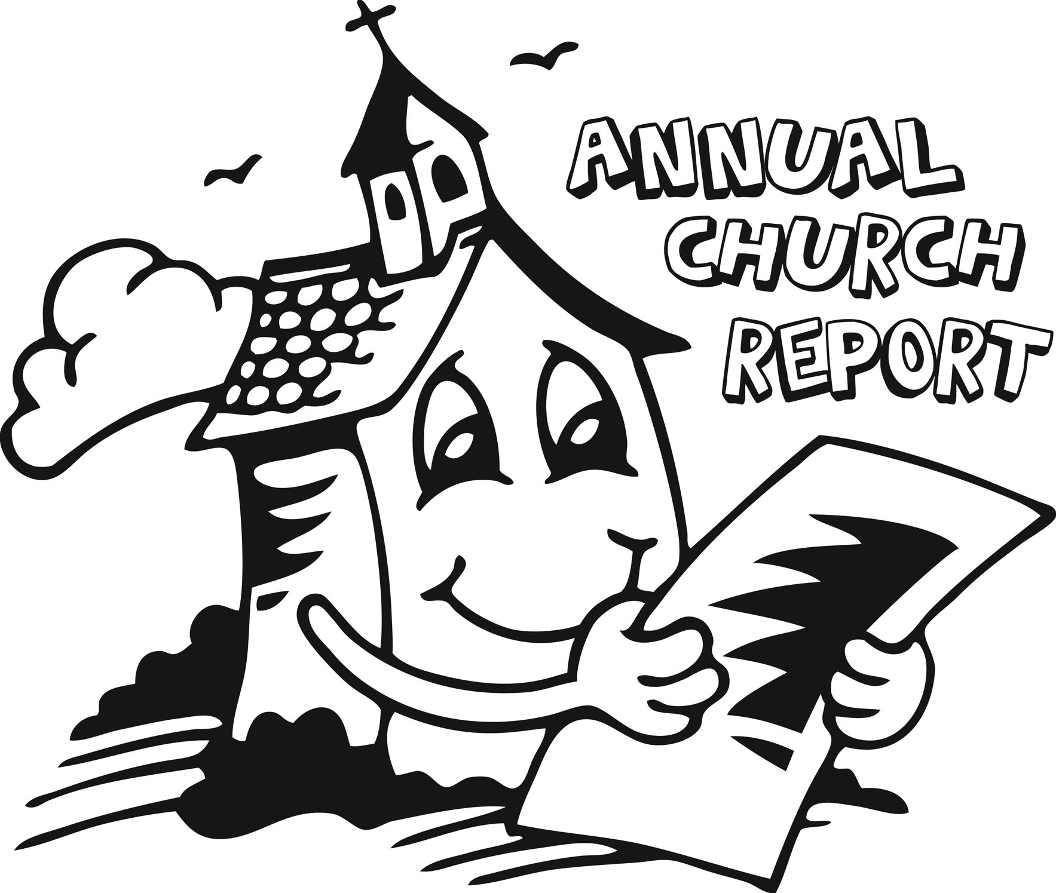

**8th GRADE CATECHISM MEETING**

The 8th Grade Catechism students and parent meeting has been changed to February 3rd after the service.

**D:\Color\valborder_8872c.jpg**

**COUNCIL MEETING**

Council Meeting is Tuesday, February 12th at 7:00 p.m. in the LYF room.

**D:\Color\valborder_8872c.jpg**

**LCW MEETING**

LCW Meeting is Wednesday, February 13th at 1:00 p.m. in the fellowship hall.

**D:\Color\valborder_8872c.jpg**

**SUPPORT OUR CATECHISM FAMILIES**

We need volunteers to provide a simple snack every Wednesday for 10 Catechism students from 5:45-6:00 pm. Sign-up sheet is on the back bulletin board. In addition, all are welcome to join us for evening Vespers from 5:30-6pm.

**D:\Color\valborder_8872c.jpg**

**2020 ENVELOPES**

**For 2020, you will need to request envelopes by either calling the church office or there is a sign-up sheet on the back table by March 1st.**

**D:\Color\valborder_8872c.jpg**

**LUTHERAN WITNESS SUBSCRIPTIONS**

If you would like to get your own Lutheran Witness the cost of one year subscription is $22.68.  This new subscription will start with the May issue.  Just place your $22.68 in cash or check (payable to St. Paul’s) in an envelope (marked with your name and for Lutheran Witness) and place it in the offering plate or drop it off at the church office before February 25. The church will also have 2 to 3 copies that you can borrow.

**NEWSLETTER SPONSORS**

The newsletter this month is in honor of Warren Thies’ 85th birthday.

Please contact the office if you’d like to sponsor the newsletter. The cost is $37.



**D:\Color\valborder_8872c.jpg**

**BAPTISMAL BIRTHDAYS FOR FEBRUARY**

We are listing Baptismal birthdays to remember and celebrate the day we were adopted into the family of God through the washing of the Holy Spirit. Those having Baptismal birthdays in February are:

Keri Lane, Steven Thies 1

Kailea Ewoldt 2

Warren Thies, Brooklyn Leitz 4

Mark Bretthauer, Ryan Pithan 6

James Pohlman 8

Megan Peitsch 9

Becky Miller 10

Dennis Mordhorst 11

Kim Lane 12

Ethan Kuhlmann 13

Misty Rose, Tobias Teut 14

John Neddermeyer 15

David Meadows 18

Brenner Jung 19

Torii Rose 20

Jane Ohlmeier, Linda Seieroe, Rustie Pithan22

Gary Goslar 23

Emily Sorensen 27

**D:\Color\valborder_8872c.jpg**

**“THY STRONG WORD”**

**‘**Thy Strong Word’ is a daily devotion airing at 6:25 a.m. Monday through Saturday on KDSN 107.1FM).

Feb. 4-9 Rev. Kurt Kaiser

Zion, Denison

Feb. 11-16 Rev. Merle Mahnken Immanuel, Schleswig

Feb. 18-23 Rev. David Loeschen

Bethlehem/Our Savior

Feb. 25 – Mar. 2 Rev. Richard Merrill

St. John, Charter Oak

**GOOD SHEPHERD HOUR**

This program is a ½ hour worship service heard on Sioux City, KSCJ, 1360 AM, at 8:00 am.

**D:\Color\valborder_8872c.jpg**

**LCMS MISSIONARIES AT ST. JOHN, C.O.**

****

Hello Everyone:  St. John Charter Oak will be honored to have as our guests, Mark and Megan Mantey, current LCMS missionaries who are coming to speak to us about their work in Uganda. St. John would like to invite all the LWML’s in the Mapleton Zone to an old-fashioned pot-luck supper on Sunday, February 10th @ 5 P.M.  Please, come, share a meal, and re-unite with friends in the Mapleton Zone. Your husbands are welcome!

**D:\Color\valborder_8872c.jpg**

**SUGGESTIONS FOR A SAFE WINTER**

At times, services may be held in less than ideal conditions. We encourage those with special concerns for dangerous conditions to use suitable caution. Reasonable effort will be made to have sidewalks clear, and ice melt placed where needed. Be cautious of the north parking lot, especially on mornings after a thaw and refreezing.

If the weatheris so severe that services are cancelled, it will be announced on KDSN radio: 107.1 FM and 1530 AM, and posted on church facebook and website. We will also use membercaller in the event of a cancellation. Please make sure we have your current phone number.