ST. PAUL’S EVANGELICAL LUTHERAN CHURCH
Church Office Number: 885-2221
Pastor LaBoube office #: 712-881-2243; cell: 712-840-1652
Elders: Bruce Mohr: 712-269-8771; Todd Teut: 712-269-7154; John Thies: 712-882-3379; John Greder: 712-269-8337

August 2018

Message from the Elders……..
August is upon us and that marks the Back to school shopping and for some of us the anticipation of Football season starting. Let us not get too busy to remember Gods rich blessings that he has provided for us.
We also welcome Pastor Nathan Peitsch, his wife Megan, and their three children Micah, Josiah, and Hannah to our calling at St Paul Ute. We also remember in our thoughts and prayers the many congregations that have a vacancy including the Triple parish and St Paul Fort Dodge where Pastor Peitsch is coming to us from.

The Lord says to us in Jeremiah 3:15 “And I will give you pastors according to mine heart, which shall feed you with knowledge and understanding."

St Paul’s Elders

AFRICAN WORSHIP SERVICE
On Sunday, August 26 we will have a joint service at St. Matthew, Mapleton at 9:00 a.m. Pastor LaBoube will be leading an African Worship Service. No morning service at St. Paul’s.

Installation Service for Pastor Nathan Peitsch will be Sunday, August 26 at 2:00 p.m. A reception will immediately follow. All St. Paul’s members are invited to attend as well as other interested parties within the community.

PANTRY SHOWER
Help us welcome our New Pastor and his family with a donation of non-perishable items for the Pantry Shower. There will be a box at the back of the church through August 25.

PASTOR COMPUTER FUND
We are requesting donations for a new computer for the incoming pastor. An offering plate will be located in the back of church August 12 & 19.
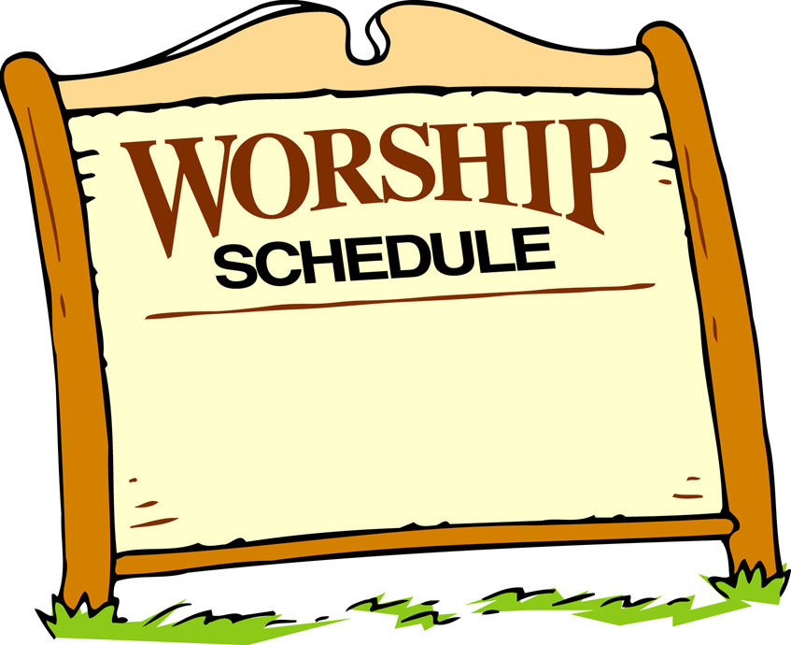
Starting Sunday, Sept. 2nd Worship Service
will be at 10:00 a.m.

Sunday School classes will start on Sunday, September 9 at 9:00 a.m.

JUNIOR HIGH YOUTH GATHERING
The Junior Youth Gathering will take place October 27-28 at the Sheraton in West Des Moines. The theme is “DELIVERED” with the focus being on Baptism. Rev. Ben Johnson from Gloria Dei will be the main speaker, Swen and Dean will once again be our entertainment, and the inflatables will be back!

RAGBRAI

St Paul pie fundraiser
THANK YOU so much for the volunteers, donations, and pies for our fundraiser! St Paul’s and St Mathew made a proud showing at the event. We had almost 1500 pieces of pie and sold out in 3.5 hours!!!
When I get all the figures together I will share the results in detail but we cleared around $3500.00! Thank the Lord for our success! The proceeds will go to the general fund!
Proud of my congregation
Tammy Bramley, Steward Secretary

THANK YOU so much for the volunteers and donations with the LYF Spaghetti Dinner.

BAPTISMAL BIRTHDAYS FOR AUGUST

August Baptismal Birthdays:
Larry Meadows, Theodore Nutt 1
Thomas Sorensen 2
Ashley Ewoldt, Herman Neddermeyer Jr., 3
Macie Rubida
Bill Creese 6
Ramona Pithan 7
Brock Nelson, Melissa Josephsen 10
John Manley 14
Shawn Goslar 15
Terry Watke 16
Tadd Eneboe, Christopher Thies 17
Michael Mordhorst 18
Kristal Mordhorst 19
Henry Buschmann Jr. 23
Jacquelin Marth, Joyce Mordhorst, 25
Harvey Thies, Henry Mohr
Tanis Watke 26
John Greder, Brynn Leitz 28
Karen Koch, Judy Meadows 29
Jerod Thies 30
Becky Mordhorst 31

