**MAY 2017**

ST. PAUL’S EVANGELICAL LUTHERAN CHURCH

**Reading the Bible:** *You don’t know what you got till it’s gone*

bsence makes the heart grow fonder.” That’s what we tell ourselves when our high school sweetheart just enlisted and now has to go overseas. It’s what we tell ourselves as we’re trying to appreciate every second we have with our family while we’re together at the holidays because so many of us have kin that have moved away. But is it ever something that we say concerning the Bible? This year we are going back to our roots as Christians, encouraging every member to read the Bible every day. We can even use tools like a concordance (lists verses by topic or by the same words) to help us understand the Bible better. So last month’s goal was:

**Goal- Try using a concordance when you don’t understand a verse or a word you’re reading.**

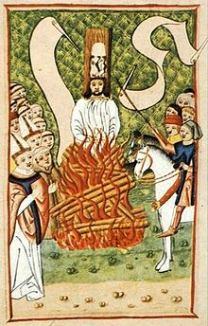

Maybe it is a good thing that we don’t say “absence makes the heart grow fonder” about the Bible. Especially if we remind ourselves of our promises that we make in our church as catechized Christians:

**Confirmation Rite**

P Do you intend to hear the Word of God and receive the Lord's Supper faithfully?

*R I do, by the grace of God.*

P Do you intend to live according to the Word of God, and in faith, word, and deed to remain true to God, Father, Son, and Holy Spirit, even to death?

*R I do, by the grace of God.*

P Do you intend to continue steadfast in this confession and Church and to suffer all, even death, rather than fall away from it?

*R I do, by the grace of God.*

Every member who is catechized and confirmed in our church promises that the Bible won’t be absent in his/her life. You promise that it is so important to you that you would die rather than lose it. That is the Christian resolve. And that confession, albeit Lutheran, predates Luther.

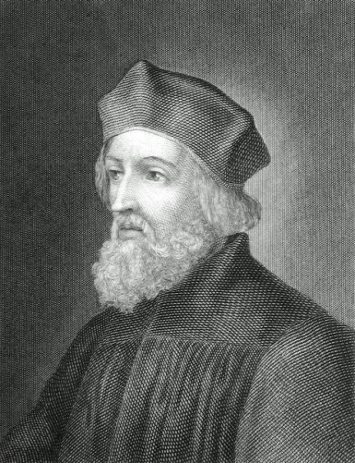

**Jan Hus (1370-1415)**

Jan or John was from Bohemia. Like Luther, he was drawn into the priesthood but influenced by John Wycliffe to encourage laymen to read the Scriptures themselves in their own language (even if it isn’t Latin). He spoke and wrote openly about the abuses of his church at the time. These problems sound familiar to Lutherans: indulgences, abuse of the Sacraments (the Mass), the Pope is not the head of the church, Scripture is the authority of doctrine. Like Wycliffe, Hus was unfairly tried by a church council, was inhumanely starved, and finally was burned at the stake for his stance that the Bible held authority even over the church. *Do you intend to continue steadfast in this confession and Church and to suffer all, even death, rather than fall away from it?* Hus said yes as his body was consumed by the flames.

**Me**

Today, there are few if any homes in our congregation that don’t have a Bible in English readily available. If not, you can bring one up on the internet with just a couple clicks. Churches, like ours, also give copies of the Bible away for free—no charge. But do we appreciate what we have? Men like Hus and Wycliffe we’re killed for something so common now that we don’t even think about the Bible being around. It is fully accessible to us but is its use absent in our daily lives? Would you appreciate it more if someone the church or country went and removed and burned all the personal bibles and deleted the Scriptures off the internet? That was Hus’s reality. So we should appreciate what we have before it’s gone.

As five catechumens will make the same promises that we and many Christians have before us, we keep them in our prayers: Kendra Creese, Katy Krohn, Thomas Sorensen, Teja Tenecyk, Jamison Thies. We not only pray for our young people but all Christians that we remain steadfast in faith to our Lord and savior Jesus Christ, by constantly hearing and reading His Word.

**Goal- Pray daily in thanksgiving for the Word of God in your home (consider the 2nd and 3rd Petitions and meanings of the Lord’s Prayer).**

**CONFIRMATION**

Confirmation questioning will be held on Wednesday, May 3rd at 7:00 p.m. All Catechism families 5th-7th Grade will host and provide refreshments afterward.

On May 7th, five eighth grade members will make a public confession of the faith given in their baptism and nurtured through years of instruction in Sunday School and weekday classes. Confirmands in 2017 are Kendra Creese, Katy Krohn, Thomas Sorensen, Teja Teneyck and Jamison Thies.



**SUNDAY SCHOOL**

The last day of Sunday School will be May 14th.

**BACCALAUREATE**

The Blessing of our High School Graduates will be during the Service on May 21st. Our graduates are: Dylan Hanson and Ashley Savery.

[Orphan Grain Train](http://www.ogt.org/)

Thank you for all the donations to Orphan Grain Train in April. The next month will be October.

**NEWSLETTER SPONSORS**

The newsletter this month is sponsored in honor of cancer patients & their families.

Please contact the office if you’d like to sponsor the newsletter. The cost is $37.

**THY STRONG WORD”**

**‘**Thy Strong Word’ is a daily devotion airing at 6:25 a.m. Monday through Saturday on KDSN 107.1FM).

May 1-6 Rev. Merle Mahnken

Immanuel, Schleswig

May 8-13 Rev. David Loeschen

Bethlehem/Our Savior

May 15-20 Rev. Richard Merrill St. John, Charter Oak

May 22-27 Rev. Marcus Manley

St. Paul’s, Ute

May 29-Jun. 3 Rev. Mark Kluzek

St. John, Kiron

**THANK YOU**

Thank you to the LYF for a delicious Easter Breakfast.

**SPIRE FUND**

As we await a final bid for the cost of replacing the spires know we have $3,000 of matching funds already given toward the spires. Consider giving to this and other needs of our congregation.

**BAPTISMAL BIRTHDAYS FOR MAY**

We are listing Baptismal birthdays to remember and celebrate the day we were adopted into the family of God through the washing of the Holy Spirit.

Kristina Leitz, Austin Leitz 3

Kendra Creese 4

Bernice Schuitema 6

Jennifer Burbridge, Jesse Thies 7

Jacob Sorensen 8

Jeffery Mordhorst, Matthew Leitz, 9

Roger Krohn

Ruth Seieroe, Elaine Vogt 11

Justin Hanson, Shawn King 12

David Hageman 13

Evelyn Thies 14

Joan Hennings 17

Fred Mohr, Carol Ullerich 18

Kimberly Creese, Korey Meseck 19

Lillian Carritt, Jean Nepper 22

Matthew Sorensen 23

Matthew Hanson 27

Travis Meadows 28

Steven Gust, Kimberly King, Nina Leitz 31



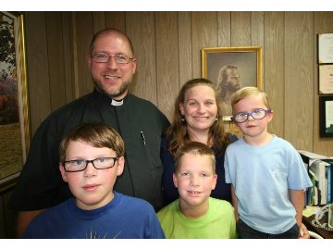

**May 5, 2017** - 1:00 pm Fritsche from Dominican Republic

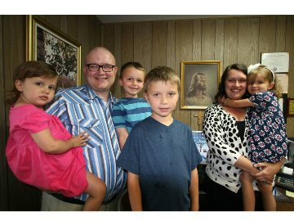

**May 20, 2017** - 1:00 pm - Sharp from Uruguay

For more information you can go to http://www.missioncentral.us/ and click on the events.

**The Denison & Mapleton Circuits’**

**Ascension Service at Mission Central**

**Thursday, May 25, 7:00 pm**

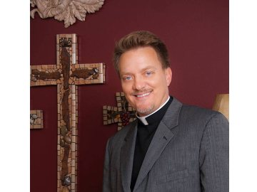

**Preacher: Rev. Greg Seltz**

**Lutheran Hour**

**Supper**

**Beginning at 5:30 p.m.   
in the M.C. Fellowship Hall**