July/August 2016
THE VOICE
ST. PAUL’S EVANGELICAL LUTHERAN CHURCH
Take it to the Lord in Prayer
“…Lord, teach us how to pray” (Lk. 11:1)

Types of Prayer
rayer, in short, is talking to God. But it really includes all times when we address God. Even our cursing “G-- D--- it!” is prayer, but not always a good one. Prayer is a response of the faith and salvation God has given by coming to us in Jesus Christ; “saying back to him what he has said to us, we repeat what is most true and sure.”
God

Us
P

The Psalms
The Psalms are all prayers written by several different authors inspired by God. With the Psalms we see prayer has a point and purpose. The Psalms all take on a theme to which all words collectively contribute. All the words of each Psalm combine in a poetic rhythm when speaking to God. The Psalms also show a wide range or types of prayers: Wisdom, Messianic, Lamentation, Imprecatory (judgment), Praise, Trust, Creation, Zion, and Liturgical (see our Lutheran Study Bible p. 846). The Psalms are meant to be prayed and/or sung daily. There are many different planners that can help you schedule them by the day and week (see Pastor).

Prayer in the Divine Service
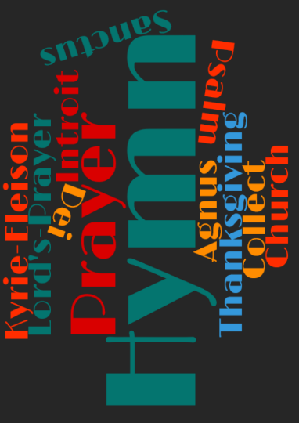
If prayer is speaking to God, then we do a lot of it when we gather together as His people. After the fall into sin, God’s people began to pray by “calling on the name of the LORD” (Gen. 4:26). Believers have been confessing (saying together the same thing) God through prayer since the beginning, both for His Mercy: not giving us the punishment that we do deserve) and
Grace: giving us favor that we don’t deserve.

The prayers we speak and sing in the Divine Service are prescribed to our lives by God’s Word in Jesus Christ and described by us as we pray them in faith.

The Posture of Prayer
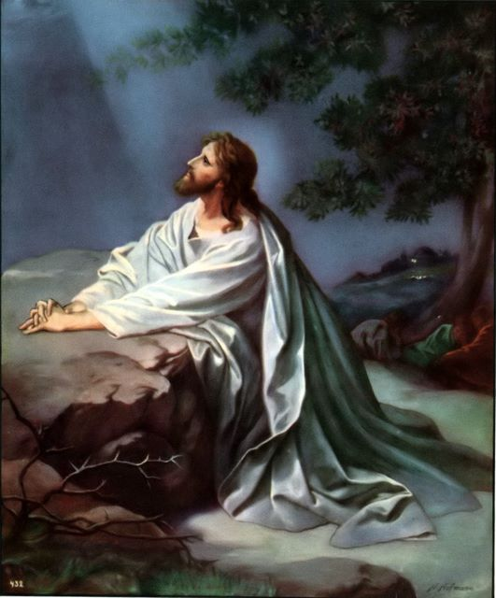
Prayer can be done in all sorts of postures. However, one’s body language communicates what one believes about the other. Therefore, our posture in prayer says what we believe about God. Our body must be instructed in how to pray in order to confess God. Jesus takes two postures in His gethsemane prayer: 1) “knelt down to pray” (Lk. 22:41) 2) “fell on His face” (Mt. 26:39). Prostration and kneeling is seen many times in the Bible as a physical act of humility, confession, or acknowledgment of the presence of God. Rarely if ever does the Bible teach us to close our eyes to pray. Prayer in the Bible is so commonly said out loud that when Hannah prayed silently Eli thought she was drunk (1 Sam. 1:13).

The Form/Structure of Prayer
Examples of Prayer in scripture are varied, and thus, show Christian freedom in our prayers. We can write our prayers, sing, read, chant, hold hands, or pray extemporaneously. Just as in all aspects of reverence toward God, order and structure are well used to curb our selfish desires and focus our attention on God rather than ourselves. To this end, the ancient Jewish form of Berakah (Blessing/Thanksgiving) Prayer has been retained in Christian Tradition. Its structure is still used for our church’s collects (general prayer that collects the day’s theme or sacrament).

Address- Who are you praying to?
Rationale- Why you are praying to him for that?
Petition- What are you praying for?
Benefit- What is the benefit of praying for that?
Closing- Who enables you to pray this way?
Using this structure is helpful in showing reverence, respect, and purpose for prayer.

The LORD’s Prayer
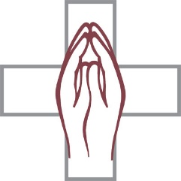
The prime model for all prayer is the Lord’s Prayer. All Christian prayer and all good petitions and requests are incorporated into the Lord’s Prayer. And yet, most of us do not know what we’re saying when we pray the Lord’s Prayer. There is an endless depth of wisdom to be learned in studying and praying this prayer. Return to be catechized and taught. Go back to your catechism. Open it up. And pray the Lord’s Prayer using the explanations you find there. This is simply how God teaches you to pray. You can spend the rest of your lifetime praying and learning this prayer.

How Prayer Works
We cannot pray on our own. We pray to God because God has come to us in Jesus and sent His Holy Spirit. Christ reconciled us with God. He paid for our sin on the cross so that through Him we can approach God’s throne of grace (Heb. 4:14-5:10). The Holy Spirit speaks to us through the Word of God. We speak back in faith, asking for what we need, trusting God knows what is best to give, and when to give it.

Daily Prayer
All Lutherans are to be taught how to pray. Just like babies learn to talk by listening to their parents, so the Christian is taught how to speak by listening to Christ’s Word. Luther, especially helped to shift Western Christendom’s emphasis on prayer away from addressing saints/people (our work) and back toward God and His Work for us and in us. Luther impressed upon fathers as the chief teachers of prayer for families. In fact, he includes a very simple way of praying every morning, mealtime, and evening in his Small Catechism. This is the easiest way to get back into the habit of praying. “Come Lord Jesus” is a relatively new tradition and is nowhere taught in the Bible or Lutheran Confessions as a table prayer, but more so and Advent prayer.

Pray
God commands prayer because He knows that proper prayer is an essential part of the Christian life of faith. God promises to listen – so He tells us to speak! “If He did not intend to answer you, He would not have ordered you to pray and backed it up with such a strict commandment” (Large Catechism). Do it. It is a discipline to be done; the same thing over and over again. It is your privilege and duty as God’s dear child. It is a gift to save you from your Me Monster. And lastly trust His Word as you pray – that’s why we say amen. Yes, yes it shall be so. Amen.
You can look forward to our Sermon Focus on Christian Prayer during the Sundays in the 2nd half of July and throughout August.

Pastor

HISTORY OF ST. PAUL’S
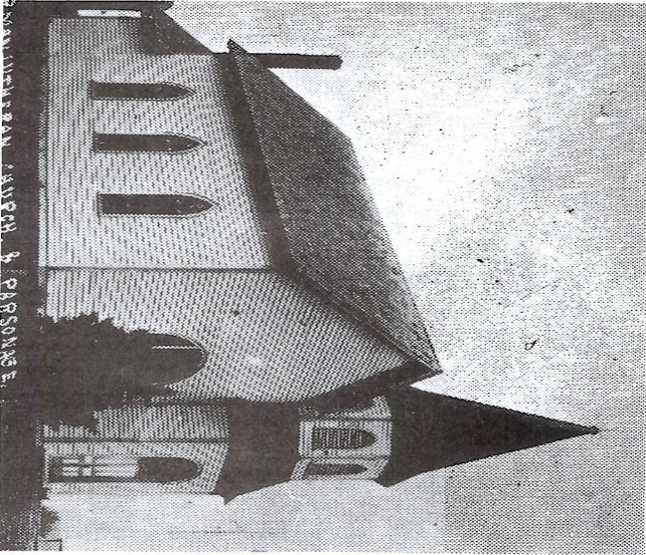
The first Church was built in 1901 at the present location and was a small frame structure.

Save the Date
March 5, 2017
Dedication Anniversary Celebration

JULY CHURCH SERVICES
Reminder no church services on July 3rd. All are invited to St. Matthew Mapleton at 8 am. On July 10th we welcome Pastor Dennis Maaske and his wife Katherine from Omaha, and St. Matthew members who will join us for services at 10 am. Reminder Communion service for July 3rd is moved to July 31st.

QUARTERLY MEETINGS
The regular Quarterly meetings will take place in July. On July 20^{th,} Trustee’s will meet at 6:30 p.m., Council will meet at 7:00 p.m., and Elder’s Mtg at 8:00 p.m.
The Voter’s meeting will be Sun., July 31 after church in the fellowship hall.

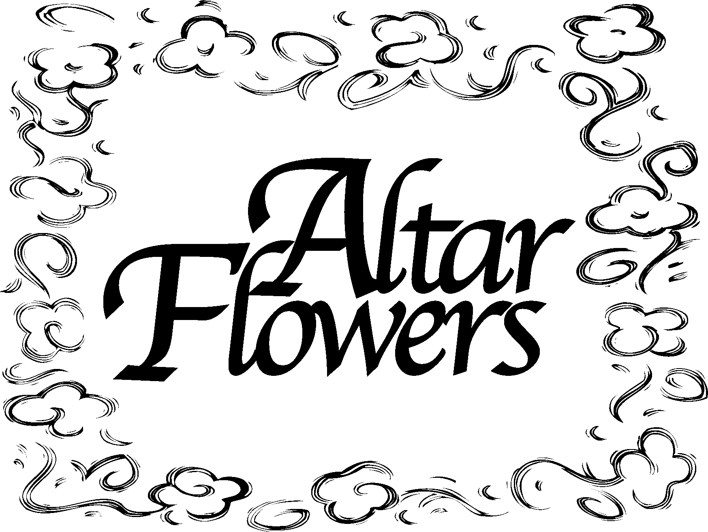

Thank you to Donna Timm’s family for donating the flowers in honor of her birthday & her and Norman’s wedding anniversary in June.
Thank you to Leonard and Joan Trimpe for donating the flowers in July in honor of their wedding anniversary on July 12.
Thank you to Don Petersen for donating the flowers in August.

If you would like to provide flowers for a month of 2016, please sign the sheet in the back of the church. Barb Mordhorst is the contact person for any questions.

GUEST MISSIONARY
On July 17, Pastor Schumacher will be our Guest Preacher and will have short presentation after the church service.
On July 16th Pastor Schumacher will also be given his presentation at Mission Central at 1 PM.
Rev. Steven and Cynthia Schumacher serve the Lord as career missionaries of The Lutheran Church-Missouri Synod in Ghana, West Africa. In this role, Steven teaches courses in Lutheran
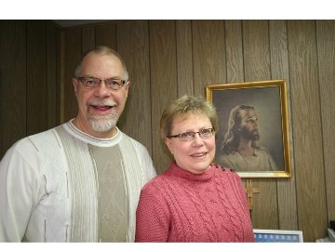

theology at the seminary of the Evangelical Lutheran Church of Ghana. (ELCG) in Accura, Ghana. He also assists the ELCG with their deaf ministry efforts. In addition, Cynthia assists in the ELCG Lutheran schools as a teacher. Steven is from Concordia, Mo., and his current home congregation is Zion Lutheran Church in ~Fort Wayne, Ind. He earned his bachelor's degree in industrial design technology from Central Missouri State University, Warrensburg, Mo. and his Master of Divinity from Concordia Theological Seminary in Fort Wayne, Ind. Before becoming a career missionary, Steven served as a pastor at five different LCMS congregations in Northeast and Midwest United States. He also served as the North Wisconsin District missionary to the deaf (1988-1993). Most recently, Steven served as the director of deaf ministry for Lutheran Friends of the Deaf (Mill Neck Family of Organizations) and taught as an adjunct professor of deaf ministry at Concordia, Fort Wayne. In his free time, Steven enjoys woodworking, camping and spending time outdoors. Cynthia was born, in Chester, Ill., and her current home congregation is also Zion Lutheran Church, Fort Wayne, Ind. , She received a bachelor's degree in education, with an emphasis in early childhood education and English literature, from Concordia Teachers College, Seward, . Neb. (now known as Concordia University, NE) Please pray for Steven and Cynthia as they serve the Lord in Ghana. Pray that God gives them safety as they travel to their location in Accra, Ghana. Ask God to give them peace as they transition to life and ministry in Ghana. Please also pray for the students who receive Steven's instruction that their hearts and minds are open to God's Word.

LCW NEWS
The 1:00 PM meeting with 7 members attending was brought to order by Joan Trimpe. The secretary’s minutes were read and approved. The treasurer reported receipts of $75 and disbursements of $20 with a balance of $818.45 on June 8, 2016.
Old Business:
Items donated to IOWAY were cell phones, tapes and ink cartridges. The sign up sheet for flowers was discussed. The Norman Timm family donated two bouquets for June in memory of wife and mother. Evelyn Thies donated two vases for future use. We decided to continue with the sign up sheet. Creta Teut has asked to be taken off the flower committee and altar guild. Teresa Mordhorst will take over her duties for Dec. on the flower committee.
New Business:
Pres. Trimpe reported on a book entitled “The Mother of the Reformation” given to her to read by Pastor Manley. She will make the book available to anyone interested in reading it. It is a biography of Kati Luther, Martin Luther’s wife, and seems to be very interesting and informative.
It was announced that Marge Neddermeyer will be the new Zone President starting in Sept. 2016.
We will contact Pastor as to any needed help with VBS.
There is no meeting in July. Teresa M. made the motion to not have a meeting in August, seconded by Barb M., motion carried…no meeting in August. The next meeting will be Sept. 14 at 1:00 PM.
Teresa Mordhorst, Secretary

NEWSLETTER SPONSORS
The newsletter this month is sponsored by Eldon & Creta Teut in honor of their 59th wedding anniversary on July 19th.
Please contact the office if you’d like to sponsor the newsletter. The cost is $37.

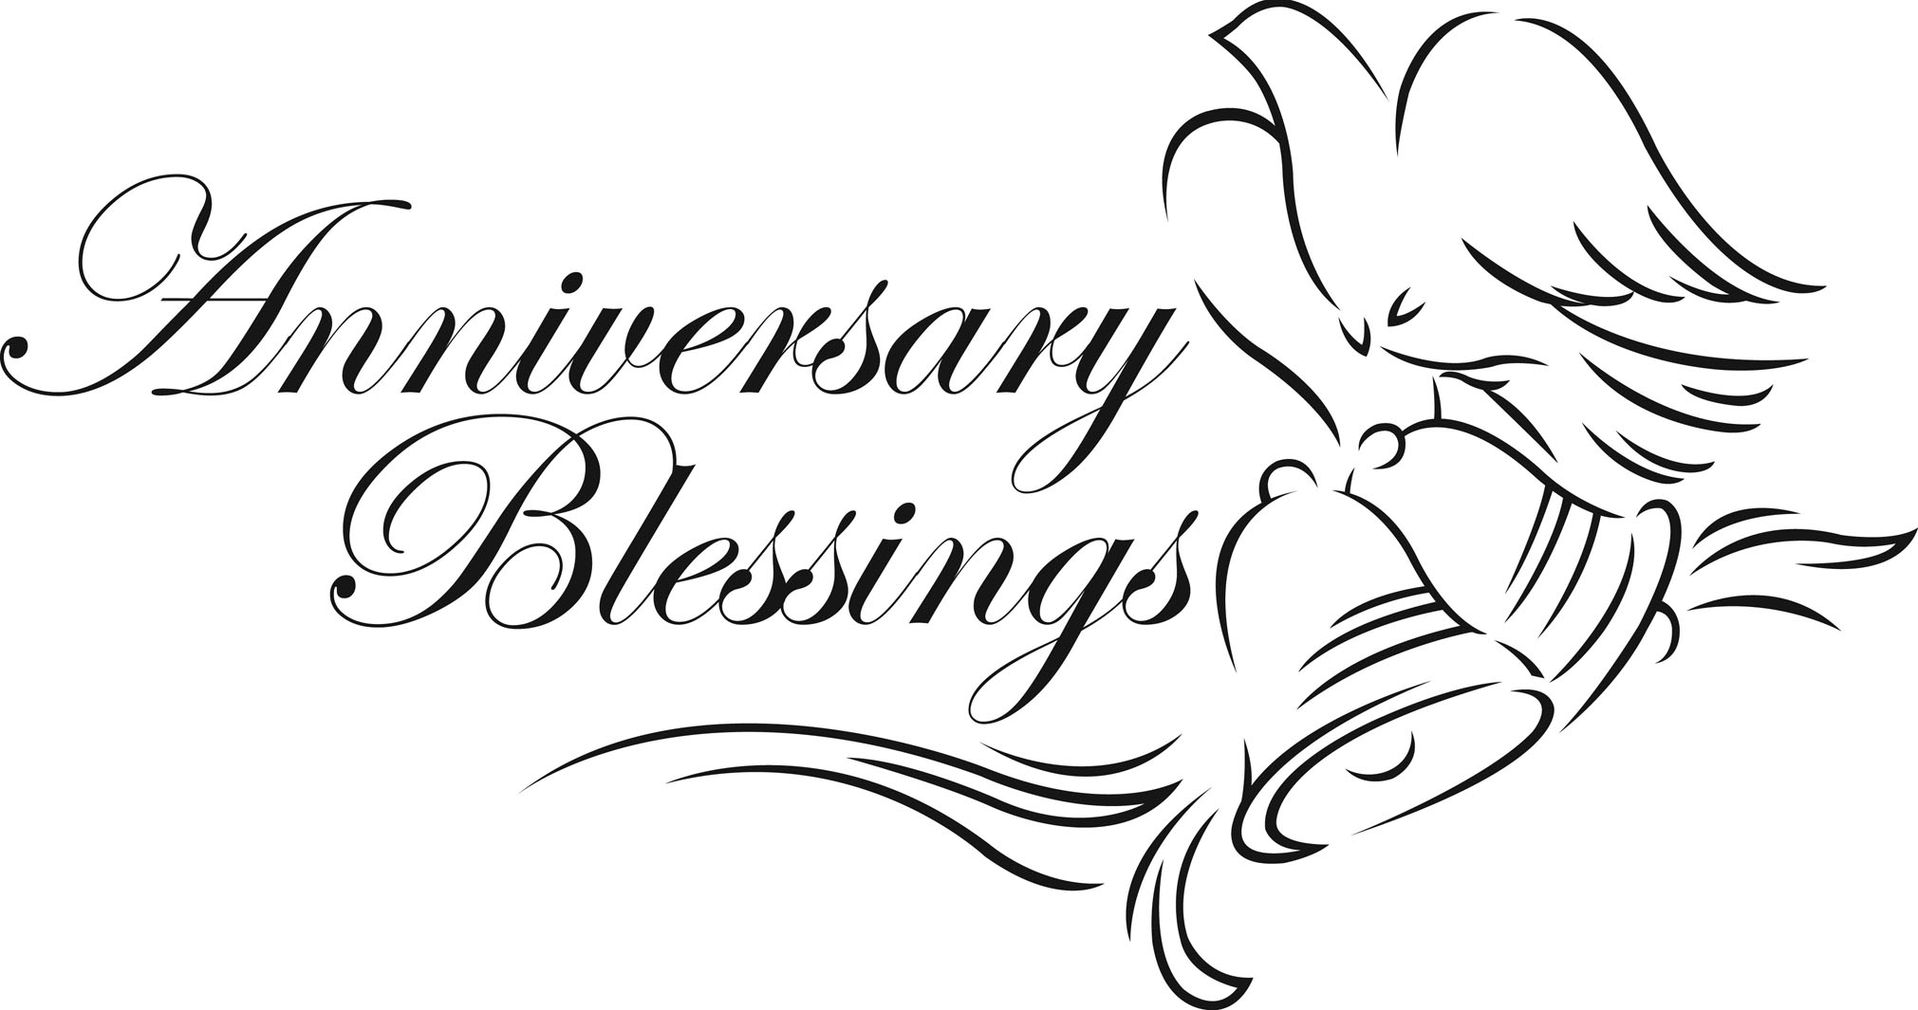

BAPTISMAL BIRTHDAYS FOR JULY/AUGUST
We are listing Baptismal birthdays to remember and celebrate the day we were adopted into the family of God through the washing of the Holy Spirit. Those having Baptismal birthdays are:

July Baptismal Birthdays:
Bette Amunson 2
Kellen Anderson, Debra Nutt, James Thies 7
Teagyn Greder 10
Deanne Hanson 11
Nathan Mohr 13
Barbara Hanson 14
Nina Hull 16
Doris Thompson, Jase BeBout 17
Phillip Hinds 20
Elizabeth Jones 21
Brook (Bretthauer) Shufflebarger 22
Terri Mohr 23
Derek Meadows, Nicholas Meadows 26
Dorothy Gust 29
Kenneth Amunson, Gordon Carritt, 30
Brittany Christiansen
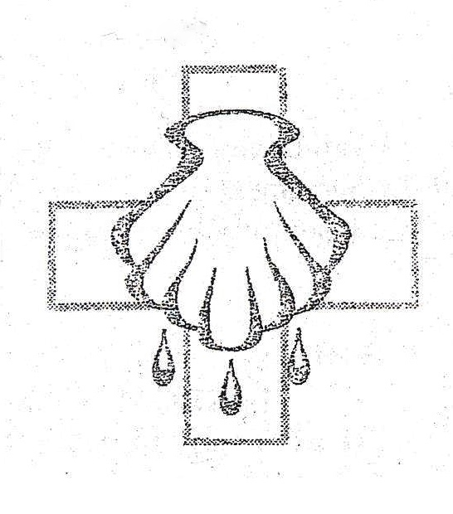
August Baptismal Birthdays:
Larry Meadows, Theodore Nutt 1
Thomas Sorensen 2
Ashley Ewoldt, Herman Neddermeyer Jr., 3
Macie Rubida
Bill Creese 6
Brock Nelson, Melissa Josephsen 10
John Manley 14
Shawn Goslar 15
Terry Watke 16
Tadd Eneboe, Christopher Thies 17
Michael Mordhorst 18 Kristal Mordhorst 19
Henry Buschmann Jr. 23
Jacquelin Marth, Joyce Mordhorst, 25
Harvey Thies, Henry Mohr
Tanis Watke 26
John Greder 28
Jerod Thies 30
Becky Mordhorst 31

“THY STRONG WORD”
‘Thy Strong Word’ is a daily devotion airing at 6:25 a.m. Monday through Saturday on KDSN 107.1FM).
July 4-9 Rev. Kurt Kaiser
Zion, Denison
July 11-16 Rev. Timothy Frank
Triple Parish, C.O.
July 18-23 Rev. Ross Fritz
Trinity, Manilla
July 25-30 Rev. Mahnken Trinity, Manilla
Aug. 1-6 Rev. David Loeschen
Bethlehem/Our Savior
Aug. 8-13 Rev. Richard Merrill
St. John, Charter Oak
Aug. 15-20 Rev. Marcus Manley
St. Paul’s, Ute
Aug. 22-27 Rev. Mark Mahnken
Immanuel, Schleswig
Aug. 29-Sept. 3 Rev. Kurt Kaiser
Zion, Denison

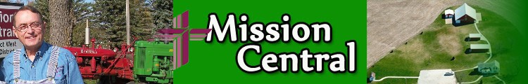

- July 9th, 2016 - 1:00 pm - Wassmunds from Korea
- July 9, 2016 : 1:30 pm - Josh and Coco Lange - Asia
- July 16, 2016 - 1:00 pm - Rev. Steve and Cindy Schumacher - Ghana
- July 16, 2016 - 1:00 pm - Rev. Carl Hanson and family - Hong Kong
- July 23, 2016 - 1:00 pm - Shara Cunningham from Kenya
- July 23, 2016 - 1:00 pm - Rev. Ahlman family - Germany
- July 30, 2016 - 1:00 pm - Graham Guenther from Korea
- August 20, 2016 - 1:00 pm - Gale family from Peru
For more information you can go to http://www.missioncentral.us/ and click on the events.

JULY HELPERS
Elder: Todd Teut
Ushers: Capt.: Gary Goslar, Kevin Vogt,
Jeff Mordhorst, Colin Mordhorst,
Landon Mohr, John Greder
Altar: Barb Mordhorst, Leanne Thies
Altar Flowers: Barb Thies
Finance: Dave Ehlers, Don Mordhorst,
Teresa Mordhorst
July 10: Acolytes: Ethan Jones, Jamison Thies
Screen: Teja Teneyck
July 17: Acolytes: Thomas & Emily Sorensen
Screen: Beau Mohr
July 24: Acolytes: Calliyah Mareau, Teja Teneyck
Screen: Thomas Sorensen
July 31: Acolytes: Ethan Jones, Teja Teneyck
Screen: Jamison Thies

AUGUST HELPERS
Elder: John Thies
Ushers: Capt.: Dave Seieroe, Mike Mordhorst,
Lois Greder, Ashley Savery,
Ashley Ewoldt
Altar: Marilyn Neddermeyer,
Donna & Tanis Watke
Altar Flowers: Joan Trimpe
Finance: Angie Teut, Chris Christiansen
Aug. 7: Acolytes: Beau Mohr, Emily Sorensen
Screen: Jenna Hanson
Aug. 14: Acolytes: Jamison Thies, Teja Teneyck
Screen: Kendra Creese
Aug. 21: Acolytes: Calliyah Mareau, Beau Mohr
Screen: Thomas Sorensen
Aug. 28: Acolytes: Kendra Creese, Jenna Hanson
Screen: Ethan Jones




VBS 2016 is “farm-tastic!” In Barnyard Roundup VBS, your children learn that Jesus gathers us together! They’ll look into the Bible, God’s Holy Word, and explore five Bible accounts where Jesus graciously gathers us together to be with Him with His abundant provision and saving protection, now and forever.
Registration is open for ages 3 to 6th Grade who will attend VBS from July 31 to August 4th from 6:00 – 8:15 p.m. Come along with us as we sing fun songs, do crazy crafts, eat yummy snacks, play awesome games, and more. Plus, you’ll learn all about Jesus our Savior and how He gathers us together! Can’t wait to see you there!
To register, register online at www.facebook.com/stpaulsute, fill out the registration form in this newsletter, call 712-885-2221, or e-mail stpaulute@gmail.com




VOLUNTEERS! Be part of Barnyard Roundup VBS! God’s children of all ages will learn that Jesus gathers us together at Barnyard Roundup VBS. AND, every child will hear the Good News that Jesus, their Savior, is with us and abundantly provides for all our needs. He also protects and saves us—now in this world and forever too! At Barnyard Roundup VBS, as VBS staff you can live out the theme “Jesus Gathers Us Together” as you share the message and the fun with kids!
If you can help full or part time, we have many ways to be involved to suit your schedule and interests. Call Leanne Thies or the church office or e-mail stpaulute@gmail.com , for more information. Join us to see how Jesus gathers us together!

CAMPFIRE AND SMORES
WEDNESDAY, AUGUST 3RD
8:00 PM
St. Paul’s VBS Closing Program
Thursday, August 4th
7:30 PM

St. Paul’s Lutheran Church, Ute
VACATION BIBLE SCHOOL REGISTRATION - 2016
(One form per child, please)
*Student Name: _________________________________________________________
*Age: ______________________________________
Gender: Male Female
*Grade entering: _____________________________
T-Shirt Size (youth): ___________________________
Allergies: __________________________________________________________________
Medical Issues or Special Needs: ________________________________________________
It would be nice if my child is placed in same group as (child's name): __________________
*Parent Name: ______________________________________________________________
*Address: __________________________________________________________________
*City: _______________________*State:________________*Zip: ___________________
*Email: ____________________________________________________________________
*Home Phone Number:_______________________________________________________
Cell Phone Number:__________________________________________________________
Other Phone Number: _______________________________________________________
Emergency Contact: _________________________________________________________
Emergency Phone: __________________________________________________________
Alternate Pickup Name: ______________________________________________________
Alternate Pickup Phone: ______________________________________________________
General Information: ________________________________________________________

Medical Release: I give my permission for the VBS staff to administer basic first aid to my child (named above) in the event of an injury. I understand that the VBS staff will contact emergency services in the event of a significant injury and all expenses for such emergency services will be paid by me.

Photo Release: I hereby grant the above named church permission to copyright and use photographs/videos taken at VBS of the minor designated above in any manner or form for any purpose lawful at any time. I waive any right that I may have to inspect or approve the finished product or written copy, that may be used in conjunction therewith, or the use to which it may be applied.

Permission to Attend: I give permission for my child (named above) to attend the Vacation Bible School (VBS) listed above. I understand that the information I give for this registration will only be used by the VBS hosting church, and that all registration information will be removed from the hosting site by December 31 of this year.

________________________________________________________
Parent Signature Date

